**Intro for powerpoint slide and also speaking parts :**

(3 slides, speaking time 1-2 mins {depending on speed of speaker})

Title slide: (slide 1)

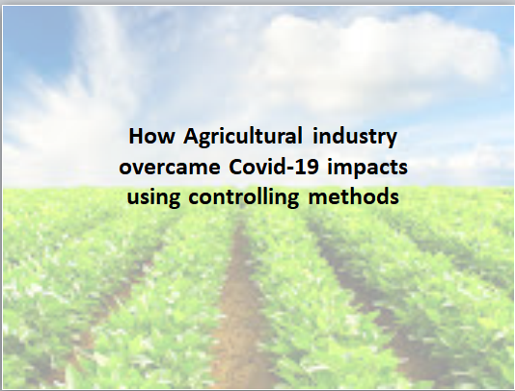

(Pic Reference: <https://leadership.ng/nigerian-agro-sector-gaps-constraints-prospects/>)

Speaker:

Hi everyone!

At this moment in time, what is the one word you hate the most?

Quarantine? Pandemic? Online-classes?

Well, if you are thinking of these words, then I dare say it will more accurate to call it by one single name:

“COVID-19”

Covid 19: (slide 2)

(Reference: <https://www.bbvaopenmind.com/en/science/research/truths-rumours-and-lies-about-the-origin-of-the-coronavirus-what-science-knows/>)

(Pic reference:

<https://www.google.com/search?q=corona%20virus%20png&tbm=isch&hl=en&tbs=rimg:CSS1iu1KHKJUYT96SZhc1nmosgIGCgIIABAB&client=firefox-b-d&sa=X&ved=0CBsQuIIBahcKEwjYmrnBpuryAhUAAAAAHQAAAAAQDg&biw=1894&bih=893#imgrc=h7DrkhOBhs74bM>)



Speaker:

Some say it was caused via a lab leak in wuhan, some say it has been spread by bats to humans, some say it’s a biological weapon made by china against the world. No matter what the case is, it’s hard to deny that this microscopic organism has ended up doing something unbelievable. It has managed to subjugate the entire world and confine almost the entire human population, in their homes!

Now who says tiny things can’t shake the world?

Well, sad to say this, but we won’t have enough time to go over all the impacts caused by it. Instead we will narrow down its effects on one specific industry that arguably was hit the worst by it. That is, the Agricultural Industry.

Agricultural industry: (slide 3)

(pic reference: <https://www.dreamstime.com/photos-images/smart-farmer.html> )

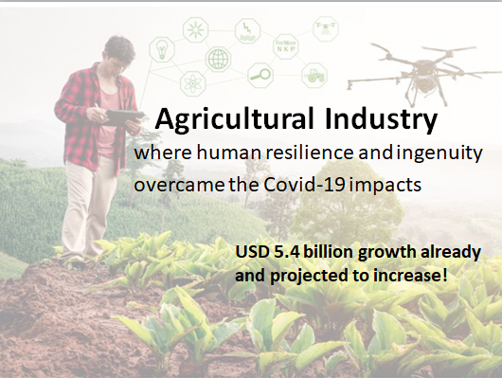

Speaker:

You might be wondering, “huh? What is this dude talking about? I can still buy and eat my favorite meal any time of the day!”

Well, that’s actually largely thanks to human ingenuity and resilience. The industry itself has controlled and managed everything so well that in most cases we don’t even feel as if Covid had any impact on it!

Moreover, statistics show that it has even flourished in such a disastrous situation, with the global feed market showing a growth of USD 5.4 billion between 2019 and 2020 and projected to continue increasing until it reaches USD 289 billion by 2021!

(Ref: <https://www.marketsandmarkets.com/Market-Reports/impact-on-animal-feed-market-183883928.html> )

But how has it done such a thing? How has it overcome the demonic curse? How has it managed to perform such a miracle? Well, that’s what we are here to find out!

Now my teammate ~~nghi (pronounce it as~~ “Ni” will take over, speaking about how it has affected the supply chain of the agricultural industries.